Table Fan
I get some PC fans scraping an old project and I decide to wire it with a USB Power Bank to create a portable fan

Use Cases:
Summer heat relief
Soldering Iron Fumes dispersion

Components
70 x 70 mm
Mounting: 60 x 60

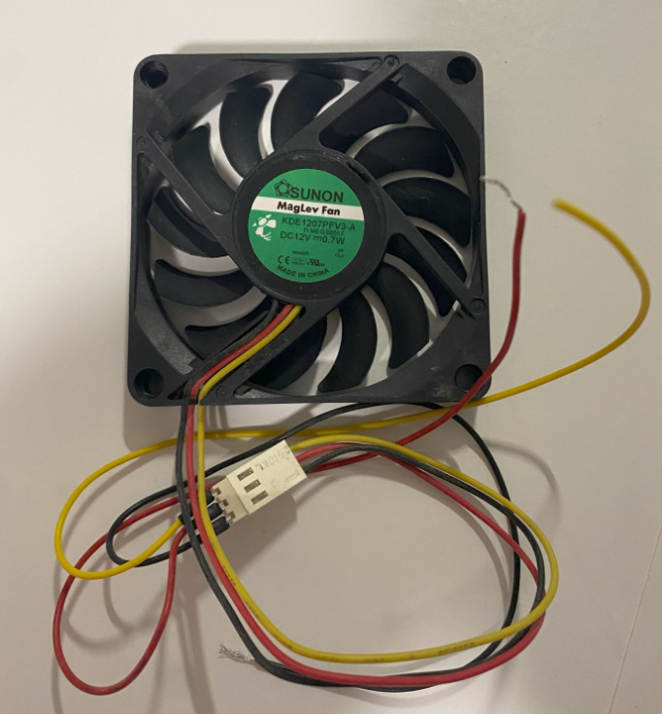

Mechanical parts

Battery Holder
Width: 78 mm
this has to align to the base jont size.
68 mm + 5 mm + 5 mm
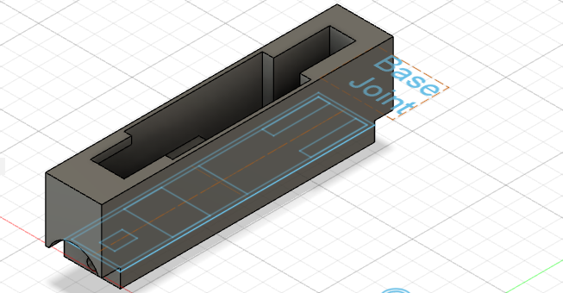

Wall Thikness: 1 mm for all sides
In past realization I use 2 mm for the side, but it is not neccessary
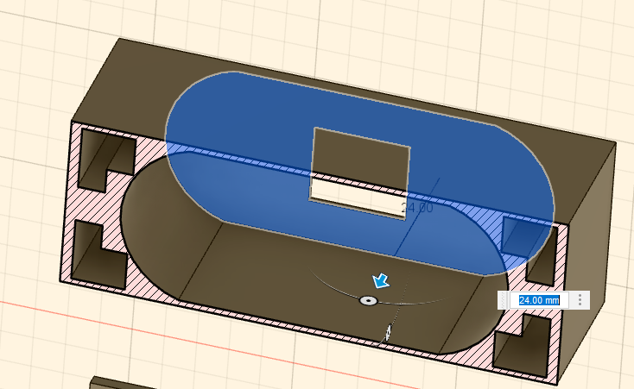

Back Window: width 11 height 13, 2 mm offset on the micro USB connector side.
This is used to charge / discarge the battery using USB-C or Micro USB connector
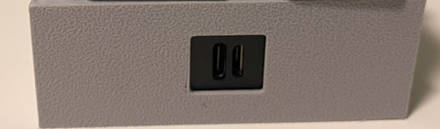

Battery housing: 2 x 27 mm circles, spaced by 33 mm, with a cut at 25 mm on top and bottom side
(in the drawing below it is 26 mm)

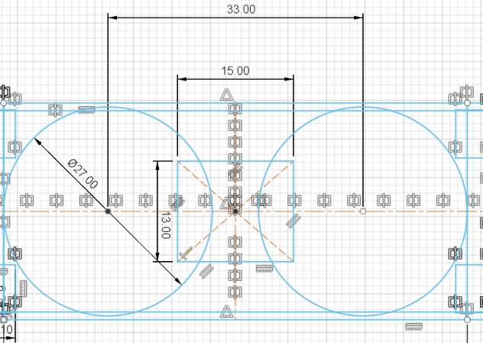

Cover Anchor: I use 4 L shaped slots that has also the fuction of saving material.
This slot generate a T shaped beam on the side of the battery holder, that make it stiff and resistent.

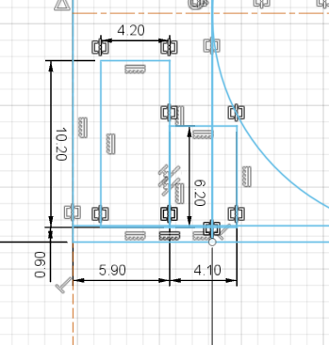

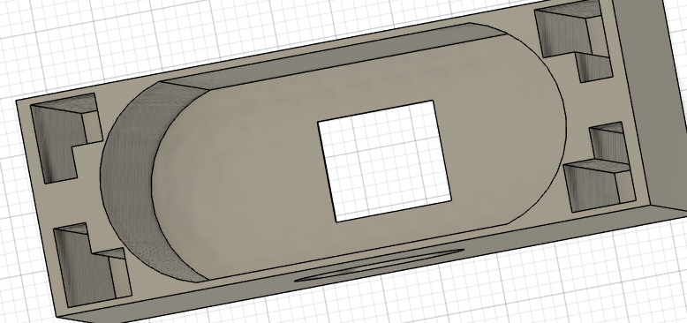

State of charge Indicator: On the top side the SOC indicator is visible
The indicator is aligned to the vertical axis and it is 41.25 mm away from the top side
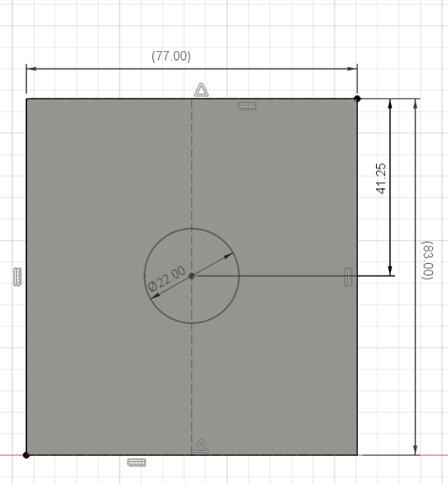

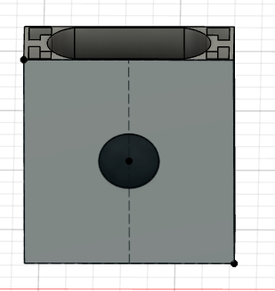

More Ideas
Can I create a Table Air Purifier?
https://amzn.eu/d/5t24OPc
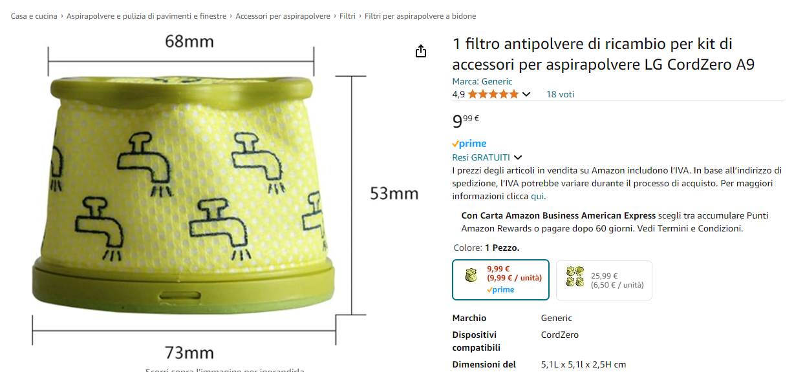

For next Iteration
Use 4 wires fan, so we can use PWM to control speed

